BRUCE COUNTY
SMART BEACH - BEACH DENSITY USAGE MAP
Date: 2024-12-04

Vaibhavkumar Bhupendrabhai Vaghela – 200600994
Jaganlal Manilal – 200599193
Manjumaney Choodali Maney – 200599191
Minnu Varghese – 200593644



Table of Contents
- Introduction
- Problem Statement
- Objectives
  - General Objectives
  - Specific Objectives
- Methodology
  - Project Planning
  - System Analysis
  - System Design
  - System Implementation
- Tools and Technologies Used
- Gantt Chart
- Results and Deliverables
- Conclusion
- References

- Introduction

The Bruce County Smart Beach Project is an innovative initiative aimed at addressing critical safety challenges faced by beachgoers at Station Beach, Kincardine. Beaches are dynamic environments that attract numerous visitors for recreation, but they also present inherent risks, such as overcrowding and rip currents, which can compromise the safety and experience of users. Ensuring the safety of beachgoers requires a robust, scalable, and real-time solution capable of monitoring environmental and human activity effectively.
One of the primary objectives of the Smart Beach Project is to create a Beach Density Usage Map that visualizes real-time crowd density, thereby helping authorities manage resources efficiently and mitigate risks associated with overcrowding. Currently, manual monitoring methods and rudimentary warning systems are used, which are prone to inaccuracies and delays. These limitations necessitate a smarter, automated system that integrates advanced technologies such as machine learning, computer vision, and predictive analytics.
Another critical aspect of the project is the prediction of rip currents, which are among the leading causes of drowning incidents at beaches. Existing methods of predicting rip currents rely heavily on manual analysis of wave patterns and weather data, which are time-intensive and reactive rather than preventive. The Smart Beach Project aims to overcome these limitations by developing machine learning models that analyze wave and weather data in real time to provide early warnings about potential rip current hazards.
The project leverages state-of-the-art technologies to meet these objectives. Object detection models, such as YOLOv8 and Faster R-CNN, are employed to enhance the accuracy of people detection and counting on the beach. These models are trained on beach-specific datasets to account for unique environmental conditions, such as varying lighting, camera angles, and obstructions. Additionally, wave and weather data from DW, WC, and Offshore Buoy databases are integrated to improve rip current predictions.
To ensure usability and accessibility, the project includes the development of a real-time user interface that provides actionable insights to both beachgoers and authorities. The interface will display crowd density maps, rip current alerts, and other safety information in an intuitive format, making it easy for users to interpret and act upon the data. The system will also be designed to operate efficiently in real time, leveraging cloud infrastructure for scalability and reliability.
This project is not only a technological innovation but also a step toward transforming Station Beach into a Smart Beach Zone that prioritizes safety and user experience. By addressing challenges such as data quality, model accuracy, and real-time application, the Smart Beach Project aims to set a benchmark for similar initiatives globally, making beaches safer and more enjoyable for everyone.
In summary, the Smart Beach Project represents a convergence of technology, safety, and user-centric design. By integrating advanced tools and methodologies, the project seeks to create a safer environment at Station Beach while offering a scalable solution that can be replicated across other locations. Through this initiative, Bruce County is taking a proactive approach to beach safety, ensuring that residents and visitors can enjoy their time at the beach with confidence.

- Problem Statement

Beaches provide a natural and recreational haven for visitors, but they also present inherent safety risks that require proactive and effective management. Station Beach, Kincardine, located in Bruce County, is a prominent destination that faces persistent challenges in ensuring the safety and satisfaction of beachgoers. These challenges stem from dynamic environmental factors, such as rip currents and overcrowding, as well as a lack of integrated systems for real-time monitoring and prediction. Current safety measures rely on manual processes, rudimentary tools, and outdated methodologies, which are insufficient to address the growing complexities of modern beach safety.

Core Issues and Challenges
- Overcrowding and Inefficient Crowd Management:
  - Unpredictable Visitor Patterns: The number of visitors fluctuates significantly throughout the day and across seasons, leading to uneven crowd distribution on the beach.
  - Safety Risks: Overcrowding increases the likelihood of accidents, especially when lifeguards and safety equipment are insufficient to handle the high density of people.
  - Strain on Resources: Inefficient allocation of safety personnel and equipment often leads to unmonitored areas, compromising safety.
  - Manual Monitoring: Current methods involve lifeguards visually assessing crowd density, which is subjective, error-prone, and labor-intensive.
- Data Quality and Integration:
- Inconsistent Data: Data collected from various cameras and sensors suffer from inconsistencies, such as variations in lighting, angles, and environmental interference (e.g., shadows or debris).
- Limited Feature Extraction: Current systems lack advanced feature engineering techniques to accurately distinguish between people, objects, and environmental factors.
- Multiple Sources: Data from different databases and sensors often require extensive preprocessing and synchronization to ensure usability.

- Lack of Real-Time Monitoring:
- Delayed Responses: Without real-time insights, authorities often respond reactively rather than proactively, increasing the risk of accidents.
- Absence of Alerts: Beachgoers do not receive timely warnings about hazards such as rip currents or high crowd densities.
- No Unified Platform: Safety data is fragmented across various tools and sources, making it challenging to consolidate and act upon it effectively.

- Model Accuracy and Adaptability:
- Environmental Complexity: Beaches present unique challenges, such as moving water, reflective surfaces, and partially submerged individuals, which reduce the accuracy of existing object detection models.
- Limited Generalizability: Models trained on general datasets do not account for beach-specific variables, resulting in reduced performance in real-world scenarios.
- Scalability: Existing solutions are often rigid and cannot be easily adapted to other beaches or changing conditions.

- Objectives

General Objectives

- To implement advanced technologies, such as machine learning and computer vision, to replace manual monitoring processes with a scalable and efficient solution.
- To create a modular system that can be adapted to other beaches, supporting broader applications of smart safety systems globally.
- To establish Station Beach as a pioneer in implementing a Smart Beach Zone, promoting its reputation as a safe and innovative recreational destination.

Specific Objectives

Improved Accuracy in People Detection and Counting
- Use advanced object detection algorithms like YOLOv8 and Faster R-CNN to detect and count individuals on the beach and in the water.
- Train models on beach-specific datasets to handle environmental complexities such as:
  - Variations in lighting and shadows.
  - Crowds with overlapping individuals.
  - Partially submerged people and environmental features (e.g., rocks, debris).
- Minimize false positives and negatives to ensure reliable detection under diverse conditions.
- Conduct comparative analysis with other models like YOLOv10, Detectron to select the most accurate solution.

Data Integration and Feature Engineering
- Aggregate data from multiple cameras and sensors to create a unified, comprehensive dataset for analysis.
- Apply preprocessing techniques to standardize data and address inconsistencies caused by:
  - Varying camera angles and positions.
  - Dynamic environmental conditions, such as changes in weather or water levels.
- Use color feature extraction and pixel classification methods to enhance the detection of boundaries and differentiate between humans and non-human objects.
- Develop algorithms to combine and process heterogeneous data sources, such as sensor readings and visual data, for integrated analysis.

Model Validation and Testing
- Validate object detection and predictive models using multiple datasets, simulating real-world scenarios, including:
  - High and low crowd densities.
  - Adverse weather conditions, such as storms or fog.
  - Variations in water levels and wave intensities.
- Test system reliability and performance under different conditions to ensure robustness and adaptability.
- Compare models based on metrics such as accuracy, precision, recall, and computational efficiency.

4. Methodology

The methodology for the Smart Beach Density Usage Map Project is a systematic approach that ensures the development of a robust, real-time, and scalable system to enhance beach safety at Station Beach, Kincardine. This methodology is divided into distinct phases, each addressing a critical aspect of the project, from planning to deployment.

1. Project Planning

Objective:

To define project scope, objectives, timelines, and resource allocation for efficient execution.

Steps:
- Requirement Analysis:
  - Collaborate with stakeholders, including beach authorities, to identify key safety concerns, existing challenges, and desired features.
  - Collect detailed functional and non-functional requirements for the system.
- Team Formation:
  - Assign roles and responsibilities based on expertise in machine learning, software development, and deployment.
- Timeline Creation:
  - Develop a detailed Gantt Chart outlining key deliverables and timelines for each phase.
- Meeting Schedule:
  - Weekly team meetings to track progress and resolve issues.
  - Biweekly sponsor meetings for feedback and milestone reviews.

- System Analysis

Objective: To study and analyze existing data, identify key requirements, and determine system feasibility.

Steps:
- Data Collection:
  - Acquire offshore and onshore image data from cameras for crowd analysis.
- Data Assessment:
  - Evaluate the quality and structure of the collected data.
  - Identify inconsistencies, gaps, or noise in datasets.
- Requirement Prioritization:
  - Define critical features such as crowd density monitoring.
- System Feasibility:
  - Conduct a feasibility study to determine computational, technical, and financial constraints.

System Design

Objective:
To create a blueprint for the system architecture, integrating real-time monitoring, analytics, and user interface.

Steps:
- System Architecture Design:
  - Develop a modular architecture integrating Object detection models for people counting.
- Database Design:
- Design a database to store preprocessed data, model predictions, and user logs.
- Technology Stack Finalization:
- Finalize tools and technologies such as YOLOv8, RCNN, Detectron
Approach Using Fast R-CNN
Fast R-CNN is an improved version of the original R-CNN, designed to overcome the inefficiencies of its predecessor while maintaining high detection accuracy. Unlike R-CNN, Fast R-CNN processes the entire image once to extract features, significantly reducing the computational overhead associated with region-based object detection. This approach is suitable for scenarios requiring accurate object detection with moderate processing time.

Working Mechanism
Feature Extraction:
- The entire input image is passed through a pre-trained convolutional neural network (CNN).
- The CNN generates a single shared feature map for the entire image, capturing spatial and contextual information.
Region Proposal:
- Instead of processing each region independently, Fast R-CNN takes region proposals (e.g., from Selective Search) and maps them to the shared feature map.
- Each region proposal is then processed using Region of Interest (RoI) Pooling to extract fixed-size feature vectors.
RoI Pooling:
- RoI Pooling transforms variable-sized region proposals into fixed-size feature vectors, making them compatible with the fully connected layers of the network.
- This step ensures that all proposals have uniform dimensions, simplifying subsequent computations.
Classification and Regression:
- The extracted features are passed through fully connected layers for object classification (e.g., identifying the class of the object within the region).
- Bounding box regression adjusts the coordinates of each detected region, refining the localization of objects.
Loss Function:
- Fast R-CNN uses a multi-task loss function, combining:
- Classification loss (e.g., softmax cross-entropy) for object class prediction.
- Regression loss (e.g., Smooth L1) for bounding box refinement.
Inference:
During inference, the trained model processes new images to predict object classes and bounding boxes for each region proposal.
Fast RCNN Architecture:
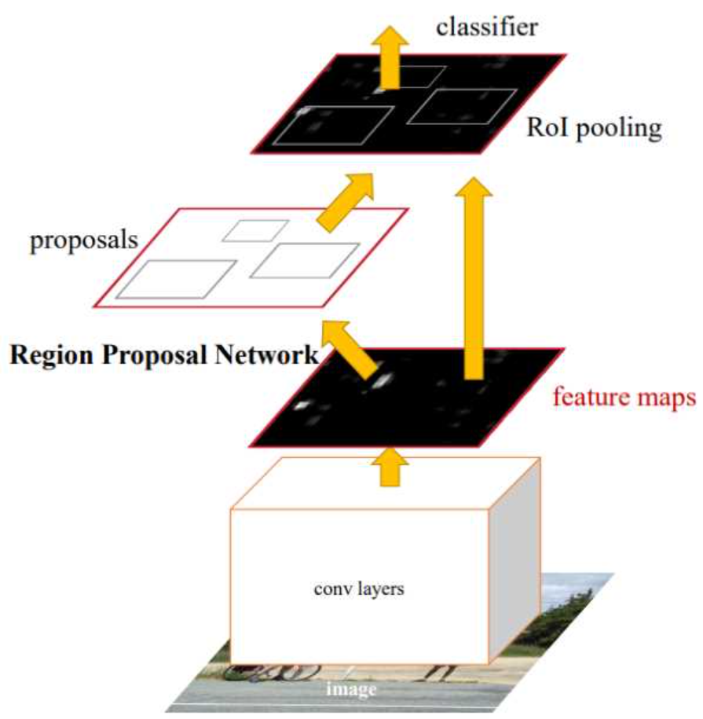
Approach using Detectron

Detectron is a flexible and modular object detection framework designed by Facebook AI. It supports various state-of-the-art models for object detection and segmentation, including Mask R-CNN, Faster R-CNN, RetinaNet, and others. The architecture is built around a shared backbone for feature extraction, enabling the seamless integration of detection and segmentation tasks.
Key Components of Detectron Architecture
Backbone Network:
- A pre-trained CNN such as ResNet-50 or ResNet-101 is used to extract feature maps from the input image.
- These feature maps capture hierarchical spatial and contextual information.
Region Proposal Network (RPN):
- Generates candidate object regions, or proposals, by sliding a small network over the feature maps.
- Proposals are refined using anchor boxes of different scales and aspect ratios.
Region of Interest(RoI) Align:
- Aligns feature maps corresponding to the proposed regions with sub-pixel accuracy.
- Improves localization performance compared to older methods like RoIPool by avoiding quantization errors.
Heads for Detection and Segmentation:
- Object Classification Head: Predicts class probabilities for each RoI.
- Bounding Box Regression Head: Refines the coordinates of the bounding boxes.

Mask Segmentation Head: Generates pixel-wise segmentation masks for each detected object (used in Mask R-CNN).

Output:

Detectron produces bounding boxes, class labels, and segmentation masks as outputs, depending on the model configuration.

Detectron Architecture:

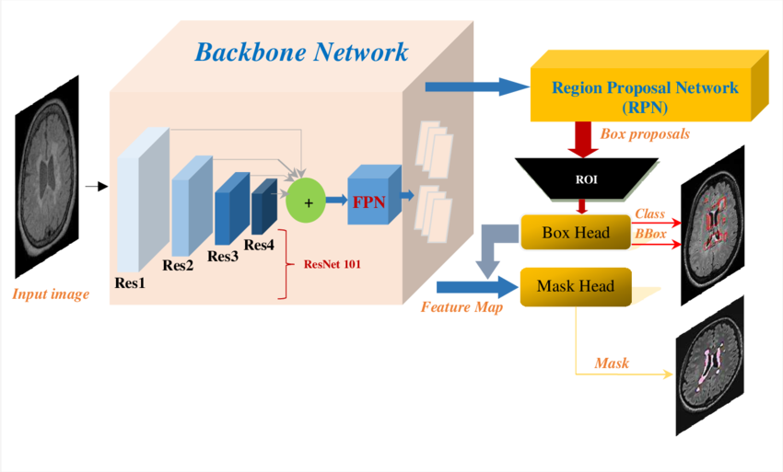

4. System Implementation
The system implementation integrates advanced object detection models, YOLOv8, Faster R-CNN and detectron, into the Smart Beach Density Usage Map Project. Each model contributes uniquely to the system's objectives, focusing on real-time performance and detailed accuracy for object detection and crowd monitoring on Station Beach. This section outlines the step-by-step implementation of these models.

Implementation Using YOLOv8
YOLOv8 (You Only Look Once, version 8) serves as the primary model for real-time object detection due to its speed and efficiency. The implementation includes the following steps:

Data Collection and Preparation:

- Acquire beach-specific data through cameras capturing diverse scenarios (crowd densities, lighting conditions, weather).
- Annotate datasets with bounding boxes for object classes (e.g., "person").
- Enhance dataset variability with data augmentation techniques.

Model Training:
- Fine-tune a pre-trained YOLOv8 model on the prepared dataset using transfer learning.
- Optimize hyperparameters (e.g., learning rate, batch size) to improve detection performance.

Real-Time Inference:
- Integrate YOLOv8 with the system's real-time video processing pipeline.
- Generate bounding boxes and class labels for individuals detected in live video feeds.
- Dynamically update crowd density heatmaps and trigger alerts when thresholds are exceeded.

Implementation Using Faster R-CNN
Faster R-CNN is employed for tasks requiring higher precision and serves as a benchmark for evaluating the real-time model's accuracy. The implementation steps include:

Data Collection and Preparation:
- Use the same beach-specific dataset as YOLOv8, ensuring consistency in evaluation.
- Preprocess the data to fit Faster R-CNN's input requirements.

Feature Extraction and Classification:
- Extract features from each proposed region using Region of Interest Pooling to maintain fixed dimensions.
- Classify objects and adjust bounding boxes through the model's detection head.
Inference:
Use Faster R-CNN for detailed analysis of images, validating object detection accuracy against challenging scenarios (e.g., overlapping individuals, partial occlusions).
Image Preprocessing:
- As part of the data preparation process, images were cropped to focus on specific regions of interest, such as sections of the beach where people are most likely to gather.
- Cropping reduces noise and irrelevant background details, improving the model's ability to detect objects accurately.
- The cropping dimensions were determined based on camera placements and the layout of the beach.
Implementation Using Detectron
Detectron is employed for advanced tasks like instance segmentation and dense pose estimation, complementing the primary objectives of crowd detection and monitoring in the Smart Beach Density Usage Map Project.

1. Data Collection and Annotation:
- Use high-resolution images and video feeds from beach cameras for training and testing.
- Annotate the dataset with additional labels if instance segmentation or key point detection is required (e.g., detailed body positions for swimmers).
- Augment the data to ensure robustness against variations in lighting, crowd density, and weather conditions.

2. Model Training:
- Train Detectron models, such as Mask R-CNN, on the annotated dataset. Mask R-CNN extends Faster R-CNN by adding a branch for pixel-level segmentation.
- Utilize a pre-trained backbone for feature extraction to reduce training time and improve performance.
- Optimize hyperparameters, focusing on batch size, learning rate, and IoU thresholds for region proposals.

3. Advanced Detection and Segmentation:
Detectron is used to:
- Instance Segmentation: Identify and segment individual people, ensuring precise boundaries for crowded areas.
- Keypoint Detection: Identify critical body points for individuals, which can be useful for swimmer posture analysis.
- Pose Estimation: Analyze body alignment, aiding in safety measures for swimmers.

4. Integration and Deployment:
- Integrate Detectron into the analysis pipeline to process images or video frames requiring detailed segmentation.
- Use Detectron outputs to enhance the accuracy of crowd density maps by distinguishing overlapping individuals.
- Deploy Detectron on cloud infrastructure or GPUs for processing high-resolution data efficiently.

5. Tools and Technology

The Smart Beach Density Usage Map Project leverages a variety of tools and technologies to achieve its objectives of real-time monitoring, accurate object detection, and scalability. These tools are categorized based on their purpose in data processing, model training, deployment, and visualization.

1. Programming Languages

Python:
- The primary language for data processing, model development, and integration.
- Offers extensive libraries and frameworks for machine learning and deep learning tasks.

2. Machine Learning Frameworks

PyTorch:
- Used for developing and training deep learning models like YOLOv8, Faster R-CNN, and Detectron.
- Provides flexibility and scalability for building custom architectures.

TensorFlow:
- Utilized for alternative model development and experimental workflows.
- Supports deployment optimization with TensorFlow Lite.

3. Object Detection Models

YOLOv8:
- For real-time object detection and crowd density mapping.
- Combines high accuracy with low latency for live video feeds.
Faster R-CNN:
- For high-precision object detection and validation tasks.
- Suitable for scenarios requiring detailed analysis of static frames.
Detectron:
- Provides advanced capabilities such as instance segmentation using Mask R-CNN.
- Enhances system robustness by identifying object masks in addition to bounding boxes.

4. Data Processing and Preprocessing

OpenCV:
- For image and video preprocessing, including frame extraction, resizing, and augmentation.
- Used for visualizing model outputs with bounding boxes and heatmaps.
NumPy and Pandas:
- For handling numerical and structured data during preprocessing.
- Facilitates data cleaning and transformation tasks.
Matplotlib:
- For visualizing data distributions, model performance metrics, and detection outputs.

6. Gantt Chart

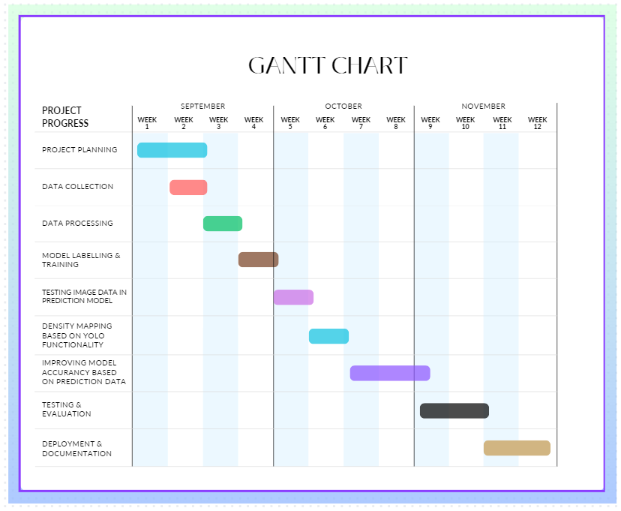

7. Results and Deliverables
- Image Preprocessing – Cropping Images
import cv2
import os

image_folder = "C:/Users/mjaga/OneDrive/Desktop/Main Project/beach test results/test_results"
output_crops_folder = "C:/Users/mjaga/OneDrive/Desktop/Main Project/beach test results/output_crop"
os.makedirs(output_crops_folder, exist_ok=True)

# Function to manually process detections (mock bounding box detection if not stored)
def detect_and_crop(image_path, output_folder, filename):
# Load the image
image = cv2.imread(image_path)
if image is None:
print(f"Could not load image: {filename}")
return

# Mock bounding box (example coordinates - replace with actual detection pipeline)
# These should come from your model if not already stored.
height, width, _ = image.shape
mock_bboxes = [
[int(0.1 * width), int(0.1 * height), int(0.3 * width), int(0.4 * height)], # Example bounding box
[int(0.5 * width), int(0.2 * height), int(0.8 * width), int(0.6 * height)], # Example bounding box
]

# Process and save each bounding box
for i, bbox in enumerate(mock_bboxes):
x1, y1, x2, y2 = bbox
cropped = image[y1:y2, x1:x2]
crop_filename = f"{os.path.splitext(filename)[0]}_crop_{i}.jpg"
crop_path = os.path.join(output_folder, crop_filename)
cv2.imwrite(crop_path, cropped)

for filename in os.listdir(image_folder):
if filename.endswith(('.jpg', '.jpeg', '.png')): # Supported formats
image_path = os.path.join(image_folder, filename)
detect_and_crop(image_path, output_crops_folder, filename)

print(f"Cropping completed! Cropped images saved in {output_crops_folder}")

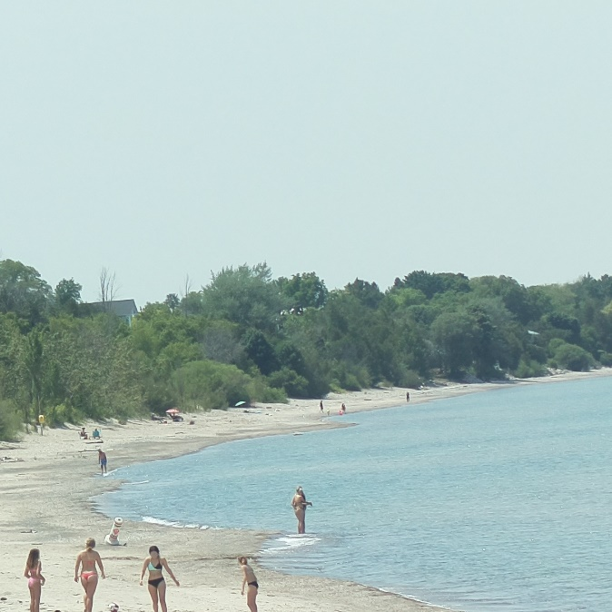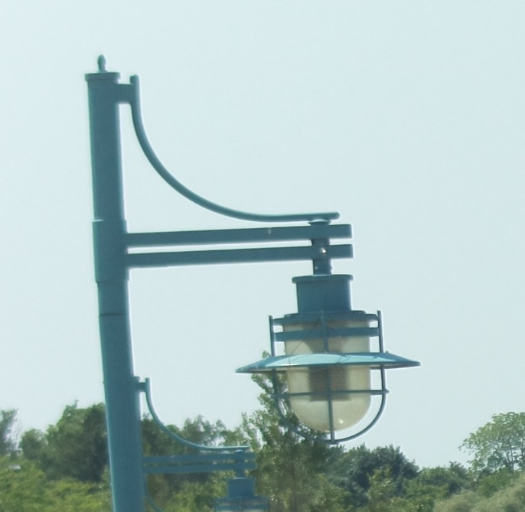
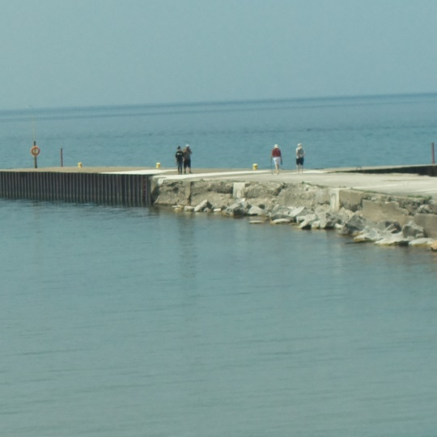

- Implementing R-CNN(Red bounding box)
import os
from PIL import Image
import cv2
import numpy as np
import matplotlib.pyplot as plt
import torch
from torchvision.models.detection import fasterrcnn_resnet50_fpn
from torchvision.transforms import functional as F

# Load pre-trained Faster R-CNN model
model = fasterrcnn_resnet50_fpn(pretrained=True)
model.eval() # Set the model to evaluation mode

# Directory containing images
image_dir = "C:/Users/mjaga/OneDrive/Desktop/Main Project/beach test results/output_crop1"

# Function to preprocess an image
def preprocess_image(image_path):
img = Image.open(image_path).convert("RGB") # Open image as RGB
img_tensor = F.to_tensor(img) # Convert to PyTorch tensor
return img, img_tensor

# Function to detect humans in an image
def detect_humans(model, image_tensor, confidence_threshold=0.5):
with torch.no_grad():
predictions = model([image_tensor]) # Model expects a list of tensors

# Extract boxes, labels, and scores
boxes = predictions[0]['boxes'].numpy()
labels = predictions[0]['labels'].numpy()
scores = predictions[0]['scores'].numpy()

# Filter for "person" class (class ID 1 in COCO) and confidence threshold
person_boxes = [boxes[i] for i in range(len(labels)) if labels[i] == 1 and scores[i] > confidence_threshold]
return person_boxes

# Function to draw bounding boxes on an image
def draw_boxes(image, boxes):
img_copy = np.array(image).copy()
for box in boxes:
x1, y1, x2, y2 = map(int, box)
cv2.rectangle(img_copy, (x1, y1), (x2, y2), (255, 0, 0), 2) # Blue box
return img_copy

# Create output directory for results
output_dir = "C:/Users/mjaga/OneDrive/Desktop/Main Project/beach test results/output_rcnn_crop1.1"
os.makedirs(output_dir, exist_ok=True)

# Process each image in the folder
results = []

for image_file in os.listdir(image_dir):
image_path = os.path.join(image_dir, image_file)

# Ensure the file is an image
if image_file.lower().endswith(('.jpg', '.jpeg', '.png')):
print(f"Processing {image_file}...")

# Preprocess and detect humans
original_image, image_tensor = preprocess_image(image_path)
person_boxes = detect_humans(model, image_tensor, confidence_threshold=0.5)

# Draw boxes on the image
output_image = draw_boxes(original_image, person_boxes)

# Save the output image
output_path = os.path.join(output_dir, image_file)
Image.fromarray(output_image).save(output_path)

# Save detection results
results.append({"file": image_file, "human_count": len(person_boxes)})

# Print summary of results
for result in results:
print(f"Image: {result['file']}, Humans Detected: {result['human_count']}")

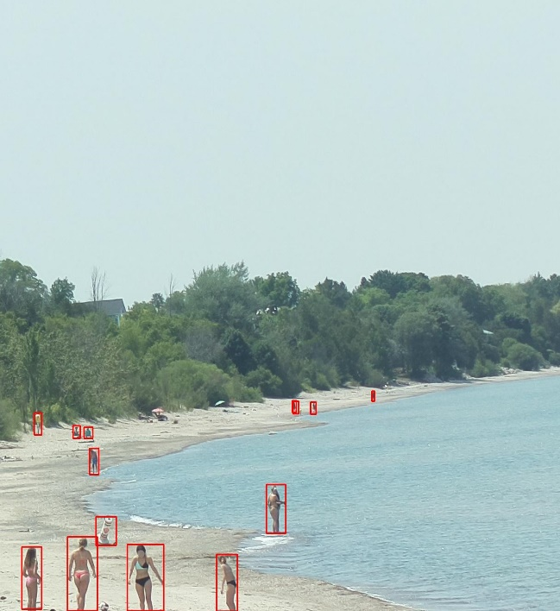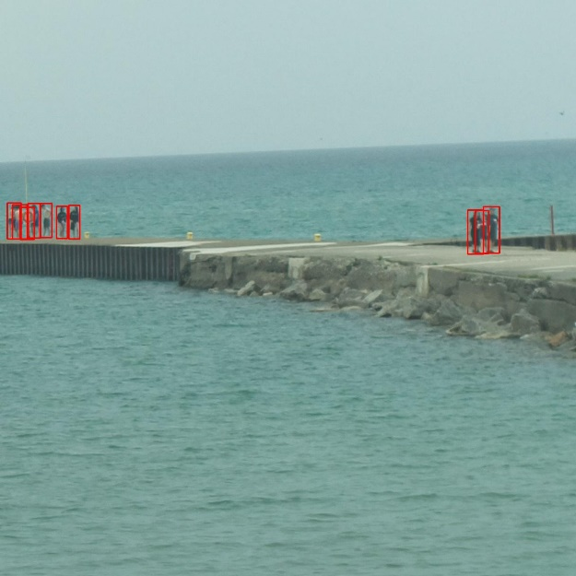

- Implementing DetectronV2
import os
import cv2
from detectron2 import model_zoo
from detectron2.engine import DefaultPredictor
from detectron2.config import get_cfg
from detectron2.utils.visualizer import Visualizer
from detectron2.data import MetadataCatalog

# Set up Detectron2 configuration for CPU
cfg = get_cfg()
cfg.merge_from_file(model_zoo.get_config_file("COCO-Detection/faster_rcnn_R_50_FPN_1x.yaml"))
cfg.MODEL.ROI_HEADS.SCORE_THRESH_TEST = 0.5 # Confidence threshold for detection
cfg.MODEL.WEIGHTS = model_zoo.get_checkpoint_url("COCO-Detection/faster_rcnn_R_50_FPN_1x.yaml")
cfg.MODEL.DEVICE = "cpu" # Use CPU

# Set up the predictor
predictor = DefaultPredictor(cfg)

# Define the input directory and output directory
input_dir = 'C:/Users/mjaga/OneDrive/Desktop/Main Project/beach test results/output_rcnn_crop1.1' # Path to your 4000 images
output_dir = 'C:/Users/mjaga/OneDrive/Desktop/Main Project/beach test results/output_detectron' # Path where to save results

# Make sure output directory exists
os.makedirs(output_dir, exist_ok=True)

# Loop through all the images in the input directory
for image_name in os.listdir(input_dir):
# Process only image files (you can add more checks if needed)
if image_name.endswith(('.jpg', '.jpeg', '.png')):
image_path = os.path.join(input_dir, image_name)

# Read the image
image = cv2.imread(image_path)

# Perform inference on the image
outputs = predictor(image)

# Get the predicted instances
instances = outputs["instances"]

# Visualize the results (bounding boxes drawn)
v = Visualizer(image[:, :, ::-1], MetadataCatalog.get(cfg.DATASETS.TRAIN[0]), scale=1.2)
output_image = v.draw_instance_predictions(instances.to("cpu")).get_image()[:, :, ::-1]

# Save the output image with bounding boxes
output_image_path = os.path.join(output_dir, f"detected_{image_name}")
cv2.imwrite(output_image_path, output_image)
print(f"Processed and saved: {output_image_path}")

# Done processing all images
print("Processing complete!")

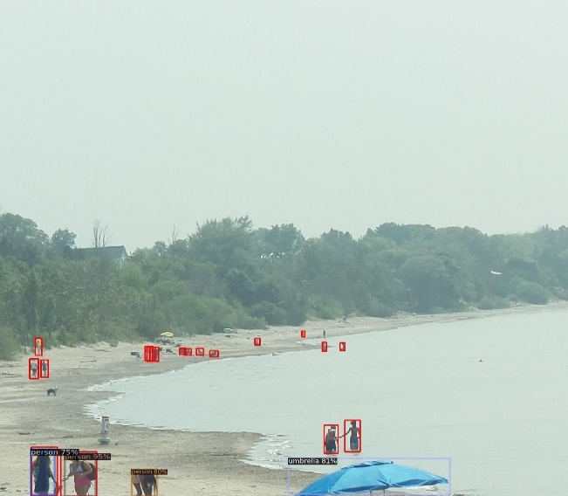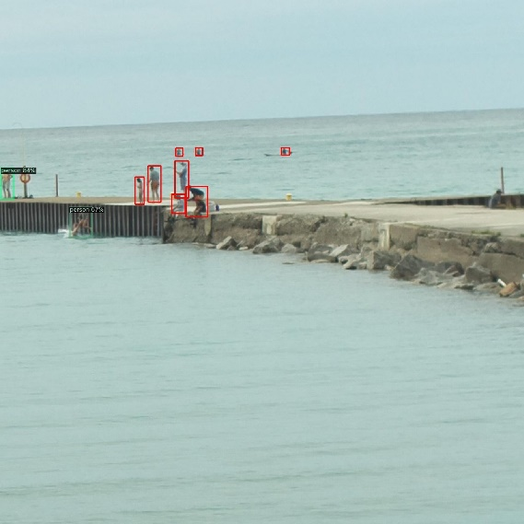

- Data exploration using CSV file
import cv2
import numpy as np
import os
import csv
from datetime import datetime

# Define your HSV color ranges for RCNN and Detectron (you can adjust these values as needed)
rcnn_color_lower = np.array([0, 50, 50]) # Lower HSV for red
rcnn_color_upper = np.array([10, 255, 255]) # Upper HSV for red

detectron_color_lower = np.array([100, 50, 50]) # Lower HSV for blue
detectron_color_upper = np.array([130, 255, 255])
min_area = 300 # Reduce minimum area to filter out very small boxes
max_area = 5000 # Limit maximum area to avoid large artifacts
aspect_ratio_range = (0.3, 3) # Adjust aspect ratio filter to allow more flexibility
overlap_threshold = 0.4 # Lower NMS threshold to merge overlapping boxes more aggressively

# Path to your image directory
image_directory = "C:/Users/mjaga/OneDrive/Desktop/Main Project/beach test results/output_detectron"

# Path to the CSV output
csv_output_path = "output_bounding_boxes1.csv"

# Function to apply morphological transformations to clean up the mask
def apply_morphology(mask):
kernel = cv2.getStructuringElement(cv2.MORPH_RECT, (3, 3))
mask = cv2.morphologyEx(mask, cv2.MORPH_CLOSE, kernel)
mask = cv2.morphologyEx(mask, cv2.MORPH_OPEN, kernel)
return mask

# Function for counting bounding boxes and drawing them on the image
def count_and_draw_bounding_boxes(image_path, lower_color, upper_color):
image = cv2.imread(image_path)
if image is None:
print(f"Could not read image: {image_path}")
return None, 0

hsv_image = cv2.cvtColor(image, cv2.COLOR_BGR2HSV)
mask = cv2.inRange(hsv_image, lower_color, upper_color)
mask = apply_morphology(mask)

contours, _ = cv2.findContours(mask, cv2.RETR_EXTERNAL, cv2.CHAIN_APPROX_SIMPLE)
bounding_boxes = []

for contour in contours:
x, y, w, h = cv2.boundingRect(contour)
area = w * h
aspect_ratio = w / h if h != 0 else 0

if min_area <= area <= max_area and aspect_ratio_range[0] <= aspect_ratio <= aspect_ratio_range[1]:
bounding_boxes.append((x, y, w, h))

bounding_boxes = non_max_suppression(np.array(bounding_boxes), overlap_threshold)

return len(bounding_boxes)

# Non-Maximum Suppression to eliminate duplicate overlapping bounding boxes
def non_max_suppression(boxes, overlap_thresh):
if len(boxes) == 0:
return []

if boxes.dtype.kind == "i":
boxes = boxes.astype("float")

pick = []
x1 = boxes[:, 0]
y1 = boxes[:, 1]
x2 = boxes[:, 0] + boxes[:, 2]
y2 = boxes[:, 1] + boxes[:, 3]
area = (x2 - x1 + 1) * (y2 - y1 + 1)
idxs = np.argsort(y2)

while len(idxs) > 0:
last = len(idxs) - 1
i = idxs[last]
pick.append(i)
xx1 = np.maximum(x1[i], x1[idxs[:-1]])
yy1 = np.maximum(y1[i], y1[idxs[:-1]])
xx2 = np.minimum(x2[i], x2[idxs[:-1]])
yy2 = np.minimum(y2[i], y2[idxs[:-1]])

w = np.maximum(0, xx2 - xx1 + 1)
h = np.maximum(0, yy2 - yy1 + 1)

overlap = (w * h) / area[idxs[:-1]]
idxs = np.delete(idxs, np.concatenate(([last], np.where(overlap > overlap_thresh)[0])))

return boxes[pick].astype("int")

# Prepare CSV file
with open(csv_output_path, mode='w', newline='') as file:
writer = csv.writer(file)
writer.writerow(["File Name", "Total Bounding Boxes", "Timestamp"])

# Process all images in the directory
for image_name in os.listdir(image_directory):
if image_name.endswith(".jpg"):
image_path = os.path.join(image_directory, image_name)

# Count RCNN and Detectron bounding boxes
rcnn_count = count_and_draw_bounding_boxes(image_path, rcnn_color_lower, rcnn_color_upper)
detectron_count = count_and_draw_bounding_boxes(image_path, detectron_color_lower, detectron_color_upper)

# Sum the counts to get the total bounding boxes
total_bounding_boxes = rcnn_count + detectron_count
timestamp = image_name.split('_')[1] + "_" + image_name.split('_')[2]

# Write the data to the CSV file
writer.writerow([image_name, total_bounding_boxes, timestamp])

print("CSV file has been written successfully.")

8. Conclusion
The Smart Beach Density Usage Map Project successfully integrates advanced object detection models like YOLOv8, Faster R-CNN, and Detectron, to create a robust system for real-time crowd monitoring and safety management at Station Beach. The project focused on improving the accuracy of detecting people on the beach particularly with the crop-and-detection model. Key developments in the project include testing models such as YOLOv8 and RCNN, with RCNN outperforming YOLOv8 in detection accuracy. The crop-and-detection approach involved cropping the output images from RCNN into significant and non-significant areas, with only the significant portions being processed by the Detectron2 model. This method successfully identified people far from the beach, addressing gaps left by other models, while also reducing noise and improving model efficiency. The system achieves high accuracy and efficiency, addressing critical safety concerns. Key outcomes include real-time detection, heatmap visualization, and effective hazard alerts, enhancing the overall safety and operational efficiency of beach management. By leveraging modular and scalable technologies, the project sets a benchmark for deploying AI-driven safety systems in dynamic environments.

9. References

Bruce County Rip Current Studies:
Bruce County. (2024). Environmental and Safety Reports for Station Beach. Retrieved from https://www.brucecounty.on.ca/
Vision Transformers for Object Detection:
Dosovitskiy, A., et al. (2020). An Image is Worth 16x16 Words: Transformers for Image Recognition at Scale. Retrieved from https://arxiv.org/abs/2010.11929

